Ideas for teaching about climate change for KS1-KS2
By Corbridge Middle School EcoSTEAM Club

Climate change is a difficult to concept for children to understand as it can’t easily be seen or touched but it affects the entire planet. Some pupils are understandably becoming concerned about the subject as they watch programmes on TV or overhear conversations. To enable pupils to really appreciate both what is happening, and why it is happening, here are some practical STEAM ideas to help answer some possible questions.

1. What is the atmosphere?

The atmosphere is the blanket of gas, including the air we breathe, that covers planet Earth and keeps us warm. This can be simply be demonstrated with a globe wrapped in a blanket.
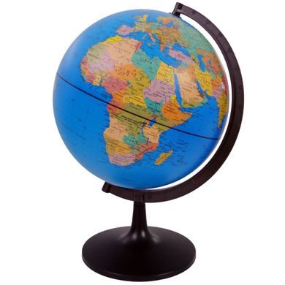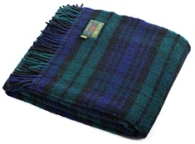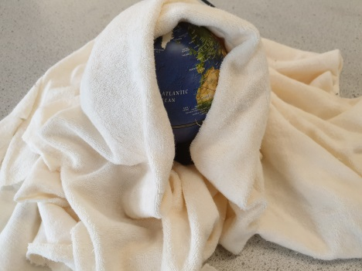

2. What is global warming?

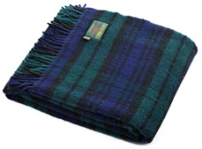
Carbon dioxide is a gas given off by burning ‘fossil fuels’ such as gas and oil that have been buried underground for millions of years. Petrol and diesel that is used to fuel airplanes or cars are produced from oil. Carbon dioxide traps more heat from the sun making the atmosphere warmer. This can be demonstrated with a globe and the addition of a second blanket.

3. Are all gases the same?

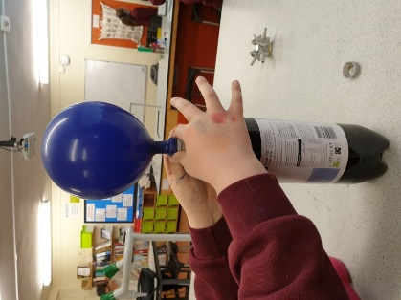
Air is a mixture of lots of gases including nitrogen, carbon dioxide and oxygen. Carbon dioxide has different properties that air and holds heat in the atmosphere. It is also heavier than air this can be demonstrated by taking a fizzy drink, placing a balloon over the bottle and shaking it gently until the bottle fills with carbon dioxide. Then fill up a second balloon by blowing into it or using an air pump.

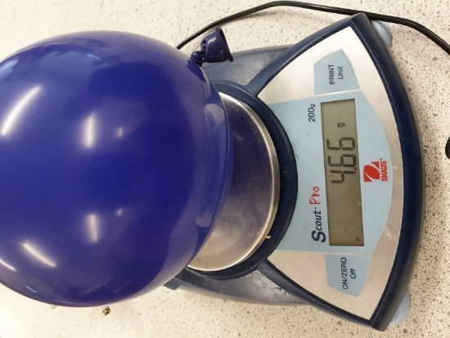
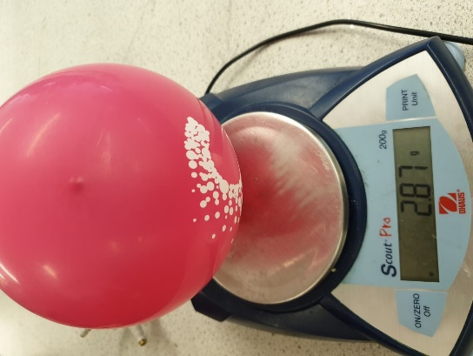
Place the two balloons on a balance and you can see the difference in mass.

4. Why is it called the greenhouse effect?

The greenhouse effect is the process by which heat from the atmosphere warms the Earth's surface to a temperature above what it would be without its atmosphere.
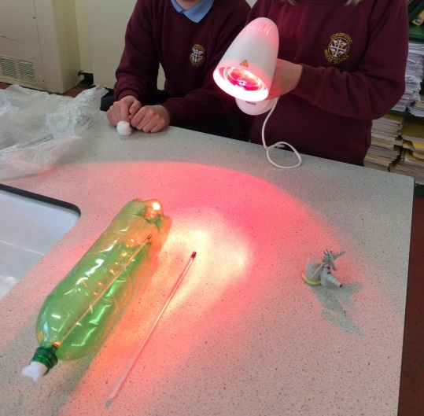
If you have access to a thermometer, a plastic bottle and a lamp (not an LED) you can try the following:
- Place the thermometer on the table. Shine the light on it for 2 minutes. Measure the temperature.
- Place the thermometer in a bottle. Put some cotton wool in the opening. Place the lamp at the same distance away and shine the light on the bottle for 2 minutes. Measure the temperature again.
You should find that the temperature measured in the bottle is higher than that outside the bottle. This is because the heat becomes trapped – this is the same as the effect of increased carbon dioxide in the atmosphere.

5. Will sea levels rise?

Much of the water on Earth is still held in glaciers and the Arctic and Antarctic ice sheets. As the Earth warms up this ice is melting. The increased levels of water will cause sea level rises – coastal cities such as Newcastle and London may get flooded more frequently. In addition, the animals that use the ice as habitat, including polar bears, seals and penguins, find hunting for food much more difficult as the ice breaks up.

You can model rising sea levels by freezing blocks of ice and placing them in a large container with some water. Put some of the ice straight into the water, like sea ice, and other bits on a stand, like the land-based icesheets. Mark the initial water level. Use model animals to help make it realistic. The ice will melt, the water level will rise and the animals will fall into the sea. Polar bears, seals, walruses and penguins all evolved to use ice for hunting or reproduction. Without the ice they may not survive.
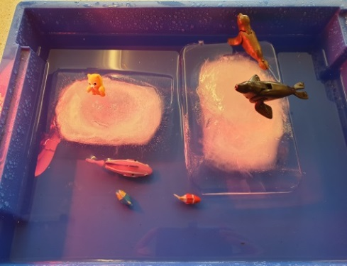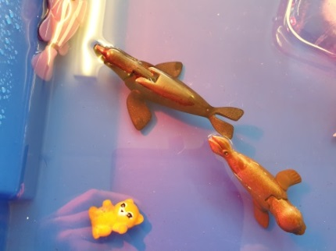

6. What is the difference between weather and climate?

The difference between weather and climate is a measure of time. Weather is the condition of the atmosphere over a short period of time. Climate is how the atmosphere behaves over relatively long periods of time. The climate has been reasonably stable for thousands of years. Increased global warming is causing the climate to change. Even small temperature changes may lead to increased storms, heavier rainfall and longer periods of drought. We are already 1ºC warmer than pre-industrial revolution levels.
There are lots of ways to encourage pupils to take an interest in monitoring the weather (e.g., from http://www.metlink.org/experimentsdemonstrations/):
- Make a rain gauge.
- Make a wind meter.
- Use a pine cone weather station.

7. Water hole experiment

To show what could happen to the creatures on land with climate change you can make a small model of a watering hole. You will need:
- Sand
- Water
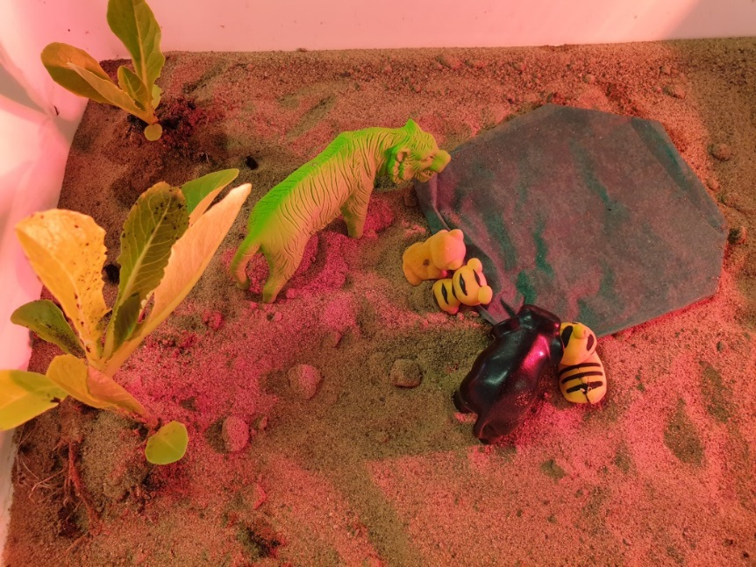
- Heat lamp (optional)
- Paper towel
- Savanna or other toy animals
- Tray
- Plants (optional)

Build the model watering hole with the damp paper towels and small plants. Arrange the animals. Use the heat lamp to make the conditions warmer or leave the model for a few days to have the same effect. The watering hole will dry out and the plants will die.

8. How does our project tie in with Dippy the Dinosaur?

The Great North Museum: Hancock is hosting a cast of bones from a Diplodocus dinosaur called Dippy. Dinosaurs are extinct – they do not live on Earth any more. Our experiments can be used to demonstrate the effect of climate change on Earth. Our climate has been reasonably stable for over 12,000 years. Animals are not able to cope with rapid changes in environment, hunting or severe loss of habitat from forests being cut down. This means many, many species are likely to become extinct. This might include lions and tigers and bears!

9. Which SDGs does climate change link to?

The SDGs (Sustainable Development Goals) are United Nation aims that we hope to reach by 2030. Climate change links to:
- SDG13 Climate Action – suggests ways in which we can reduce the causes of climate change.
- SDG4 Quality Education – everyone needs to have access to resources to help them understand how to live sustainability.
- SGD7 Affordable and Clean Energy – identifies the alternatives to fossil fuels that produce carbon dioxide when burned.
- SDG11 Sustainable Cities and Communities – ideas on how to change the way we live such as designing cities for walking rather than cars.
- SDG14 Life Below Water- the animals and plants that live in the seas and oceans.
- SDG15 Life on Land- the animals and plants that live in rivers and on land.
- SDG17 Partnership for the Goals - coming together to make life better for everyone.

