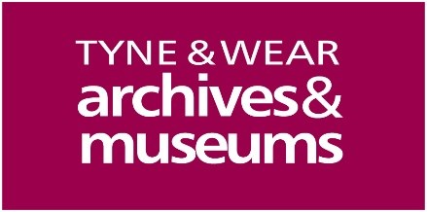
Tyne & Wear Archives & Museums
Breastfeeding Commitment

Date of approval by TWAM Leadership: 18 February 2020
Date for review: February 2023

Tyne & Wear Archives & Museums, agree to the following principles to support women breastfeeding:

- We will be welcoming of breastfeeding mothers.

Breastfeeding women need to be reassured that it is widely accepted and welcome to breastfeed anywhere. A look is important and can say 1000 words, if you happen to catch their eye, don’t stare but give a little smile and she will feel at ease.

- We will not allow any other member of the public to discriminate against breastfeeding women.

It is against the law to discriminate against a woman breastfeeding. Women are protected under the Equality Act 2010 to breastfeed anywhere in a public place. Discriminating against a breastfeeding woman may lead to prosecution.

- We will ensure our staff are friendly and polite towards breastfeeding mothers and their children.

Breastfeeding women are often nervous and fearful of the public’s reaction to breastfeeding, it is important that women are made to feel welcome.

- We will ensure that our staff are helpful and provide table service whenever possible to breastfeeding women.

A breastfeeding woman might be sitting in the same place for a long time while her baby feeds. By offering table service, this can provide a better experience for women.

- We will provide free drinking water.

Breastfeeding is thirsty work! Providing free drinking water can make sure a woman is kept hydrated while nursing her baby.

- Changing facilities will provide a changing mat (at least) or changing table and a waste bin for dirty nappies.
Babies often need their nappy changed after feeding, providing changing facilities will enable this to happen comfortably.

- We will ensure our changing facilities are kept clean and checked on a regular basis.

Feedback from women suggest unhygienic changing facilities negatively impact their breastfeeding experience.

If possible in our venue:

- We will provide a private/semiprivate area for women to breastfeed.
Some women prefer more privacy than others and would prefer to breastfeed in a designated area (but not in a toilet!). If there is no way of providing a private space, ask what can I do to help make you feel comfortable?

Although this document is specifically related to breastfeeding, these principles apply to all families, whichever feeding method they choose.

All new employees will be provided with adequate training on how to support all mothers and their children.

In addition to this document, the website below contains a short video from our local women on how they want to be supported. We will encourage all new staff to watch the video as well as reading this document.

https://spark.adobe.com/video/P7LuopiLrxv5c

The staff member responsible for the implementation of this commitment to all staff is Julie Westgarth, HR Advisor. .

This commitment has been developed in collaboration with Newcastle University, Newcastle City Council and the NHS Foundation health visiting service.

Further information on breastfeeding can be found here:
National Breastfeeding Helpline Tel: 0300 100 0212
NHS Breastfeeding Support https://www.nhs.uk/conditions/pregnancy-and-baby/breastfeeding-help-support/
