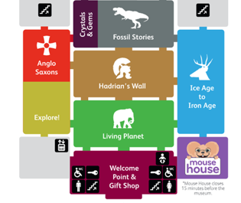
Follow the route to find all these objects in the museum!
- You can put a tick in the box when you find the object.
- This scavenger hunt starts on the ground floor. Use the map to help you find your way around.

Well done! You have now finished the Great North Museum Scavenger Hunt!
For more of a challenge, try our challenging scavenger hunt next time.

