Activity Sheet:
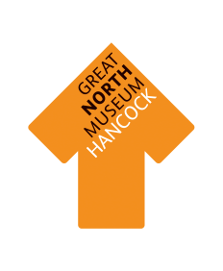
Dinosaur Groove, Look how I Move!
Walk, wiggle and flap like a Dinosaur.

Contents check list:

1 x fly walk swim dice 1 x explorer hat 1 x wind up torch

What to do:
- Take turns to wear the ‘explorer hat’ and throw the dice.
- What did it land on? (Fly / Walk / Swim)
Can you find something that could fly / walk / swim in the fossil stories gallery?
- Can you move in this way whilst you are looking? (flap, wiggle or stomp your way around the gallery)
- What did you find?
- Use the wind up torch to get a closer look.
- How do you know that it could Fly / Walk / Swim? Did it have stomping feet? Flapping wings? Swishing fins and flippers?
- Remember to take turns with the explorer hat and throwing the dice.
- Once everyone has had a turn, try to remember all the things that you found. Which one did you like the best?
At the end of this activity, please check the contents back into the bag.

Activity Sheet:
Munch, Crunch, Dinosaur Lunch!
How and what do I like to eat? Do I like plants, or do I like meat?
Contents check list:
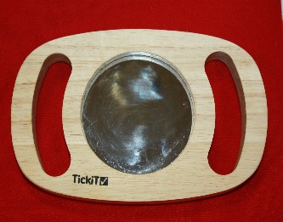

2 x Plates 1 x safety mirror 1 x Iguanodon 1 x Megalosaurus
tooth tooth
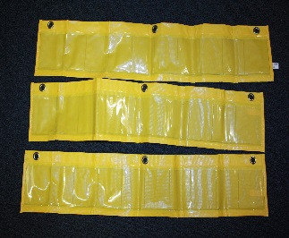

15 x Meat cards 15 x Plant cards 3 x Pocket banners
What to do:
- Look at the two Dinosaur teeth. What makes them different? What do you think they do? Which tooth would do you think would be best for eating plants, and which too do you think would be best for eating meat?
- The T-rex was a meat eater (carnivore).
Can you find the T-rex in the Gallery?
Have a look at its teeth.
- The Iguanodon was a plant eating dinosaur (herbivore).
Can you find the Iguanodon skull in the gallery?
Have a look at its teeth.
- Use the mirror to look at your teeth. Are they all the same? When you bite your food what teeth do you use?
When you chew your food which teeth do you use?
- Now it’s time to play a memory game! P.T.O
Setting up the memory game:
- Divide the group into two teams; the ‘Carnivore Team’ and the ‘Herbivore Team.’
- Mix up the plant and meat cards and place them face down into the pocket banners so that you can no longer see the pictures.
- Give each team a dinner plate.

Playing the memory game:
- The aim of the game is to fill your team’s dinner plate with 10 pieces of food first.
- The Carnivore team will be looking for the meat cards, and the herbivore team will be looking for plant cards.
- Take turns to pick two cards from the pockets.
- Do the cards match?
- If the cards match put the matching cards onto the correct dinner plate(even if it’s the other team’s).
- If they don’t match put the cards back into the pocket where you found them.
- The first team to collect 10 cards on their dinner plate wins!

If you finish this game quickly, why not reset the game and play again?

At the end of this activity, please check the contents back into the bag, including this Activity sheet.

Activity Sheet:
Little Clue, Which One’s the Poo?
Feel inside the feely bag… no peeking! Have a guess and then go seeking.

Contents check list:
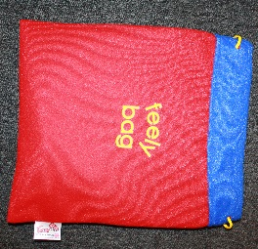

1 x Feely bag 1 x Wood slice 1 x Feather 1 x Fossil Poo
(colour may vary)

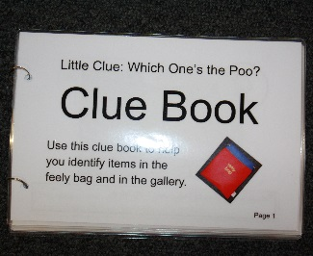
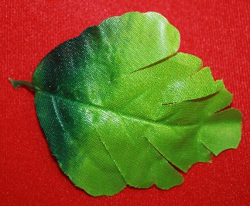

1 x Egg Shaker 1 x Artificial leaf 1 x Shell 1 x Clue book

What to do:
- Take turns in putting your hand into the feely bag, picking something up and trying work out what it might be (no peeking).
- Try to describe it.
How does it feel? Is it hard or soft? Is it bumpy or smooth? Is it cold, or warm? What shape is it?
Do you have an idea what it is?
- Next take it out of the bag. Were you right? If not what is it?
- Do you think it is real? Do you think it’s pretend?
P.T.O
- Use the clue book to find out what it is, and what to look for in the gallery.
- Find things like this in the gallery.
- Once everything has been found try remember all the things that you saw along the way. Which one did you like the best?

At the end of this activity, please check the contents back into the bag, including this Activity sheet.

Activity:
Big, Small: Measure Them All.
Use your fingers, hand and feet to measure things in the Gallery.

Contents check list:
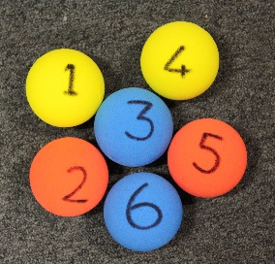
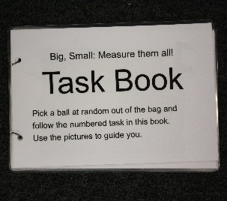

1 x T rex puppet 6 x coloured balls 1 x task book
with task numbers
What to do:
- The T-Rex has lots of tasks for you to complete.
- Use the T-rex hand puppet to pick a coloured ball at random from the bag.
- The ball will have a number on it. Match the number to the numbered task in your clue book.

T-Rex tasks:
- Measure the large ammonite with your hands.
- How many steps can you stomp from the tail of the T-rex to the head of the T-rex
- Can you find something small enough to fit inside your hand?
- Look at all of the fish through the Gallery. Can you find a fish that could swallow you whole?
P.T.O
- Count on your fingers how many squids are there for the Ichthyosaurs dinner.
- Find the rock with many holes. Do your fingers fit inside? How far up your finger does it go?

At the end of this activity, please check the contents back into the bag, including this Activity sheet.

Activity:
Dinosaur Galore! It’s Storytime!

Contents check list:

1 x Dinosaurs Galore 1 x Pteranodon 1 x Triceratops
Book wings head

1 x Spinosaurus 2 x T-rex hands
Spine

What to do:
- Settle down to read the Dinosaurs Galore book.
- When you reading the book, look at all the bits of dressing up. What dinosaurs from the story do they belong to?
- Try on some of the dressing up.
- Which dinosaur was your favourite?
- Did you find out about any new dinosaurs that you didn’t know before?
- Turn back to the page with the Pteranodon and the Ichthyosaurus. Can you find all the creatures on this page in the Gallery? Pteranodon / Icthyosaurus /Squid(Belemnite)/ Ammonite (from the corner of the page)
At the end of this activity, please check the contents back into the suitcase. (into the netting section) including this Activity sheet.

